HW # 2 Jialiang Cui

1 pt each

Use Figure 1 for Questions 1-10

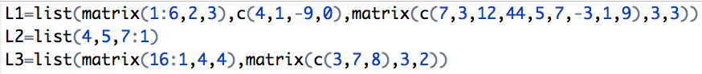

1. How many objects are there in L1,L2, and L3 combined? (Objects are referenced using “[[ ]]”)?

-- 8

1. What is sum(L1[[1]])?

-- 21

1. What is L[[3]][2,1]=5 doing?
   1. assigning the third object, which is a vector, the value 5, at the second row and first column
   2. assigning the third object, which is a matrix, the value 5, at the second row and first column
   3. assigning the fourth object, which is a matrix, the value 5, at the second row and first column
   4. assigning the third object, which is a matrix, the value 5, at the second column and first row
   5. None of the above

-- b

1. What is sum(L1[[2]])?

-- -4

1. What is sum(L1[[3]])?

-- 85

1. What is sum(L3[[2]]*L2[[2]])?

-- 180

1. What is sum(L1[[3]]+matrix(3:11,3,3))?

-- 148

1. What is sum(c(L1[[2]],1:3)-L2[[3]])?

-- -26

1. What is L3[[1]][L2[[1]],L2[[3]][6]]?

-- 9

Use functions A, B, and C for questions 11-20

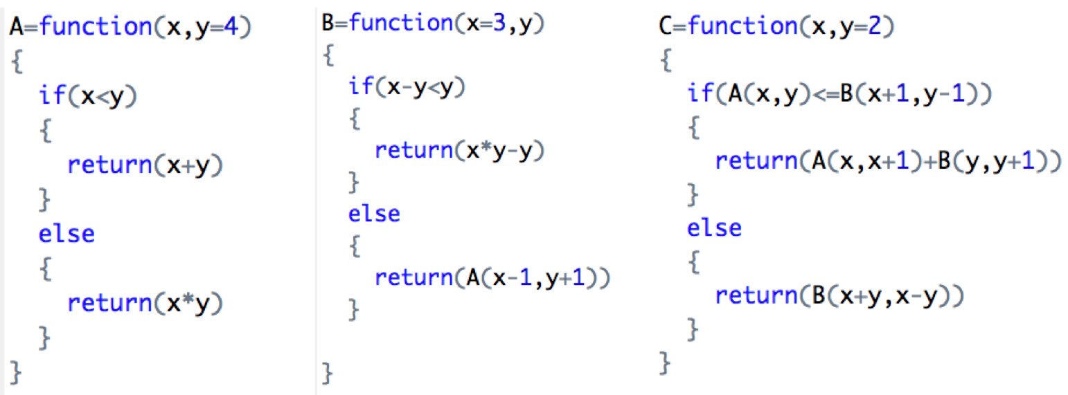

1. Which functions have an optional parameter?

-- A B C

1. How many vectors does function B have?

-- 2

1. What is A(2,3)? -- 5
2. What is B(,6)? -- 12
3. What is C(3,4)? -- 22
4. What is C(5,5)? -- 9
5. What is C(4)? -- 12
6. What is C(3)+A(2)? -- 16
7. What is C(-2,-3)? -- -8
8. What is C(B(1,2),A(2,1))? -- -1
9. For the function below, print out the “Hello, ‘fname’ ‘lname’.” Example:



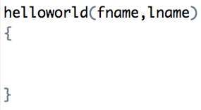

--

helloworld=function(fname,lname){

cat("Hello,",fname ,lname)

}

1. Give the function below that calculates the profit for a 1 year real estate deal:

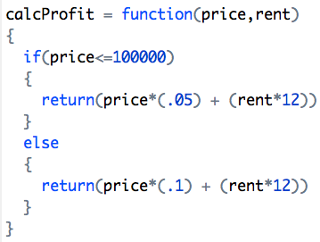

the probability table, named realProb, for prices and rents is:

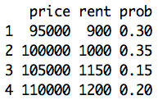

What would be the expected **PROFIT** for this investment?

-- 15550*0.3+17000*0.35+24300*0.15+25400*0.2 = 19340

1. Solve #29 using R commands and function

price = c(95000,100000,105000,110000)

rent = c(900,1000,1150,1200)

prob = c(0.3,0.35,0.15,0.2)

Profit = 0

for(i in 1:4){

Profit = Profit + calcProfit(price[i],rent[i])*prob[i]

}

Profit

1. Investment A can be bought for $10. Given the probability model for Stock A, what is expected return:

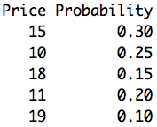

-- 0.38

1. For #31 what is the standard deviation?

-- 0.4037326

1. Calculate the ER in #31 in R.

-- price = c(15,10,18,11,19)

prob = c(0.3,0.25,0.15,0.2,0.1)

ER = sum( ((price-10)/10)*prob)

1. Calculate the risk (std) in #31 in R.

-- ret = (price-10)/10

std=sqrt(sum((ret-10)^2*prob))

std

1. Assume that stock A has an option that expires in 63 days. The stock’s current price is $100, the call option contract has a price $2.48, the implied volatility of the option is 25%, the 3 month treasury rate is 3% and the strike price of the option with the highest volume is $102. A few days before the option contract expires, the implied volatility of the option goes to 75%. What happens to the option price?

-- Option price will increase.